I.A.F.F. LOCAL 22

THE PHILADELPHIA FIRE FIGHTERS UNION

HEALTH PLAN

SUMMARY PLAN DESCRIPTION

Revised September 2016

Table of Contents

Introduction 4
Hepatitis C Policy 5
Highlights of your Health Plan Benefits 6
Contact Information 7
Abuse of Benefits Policy 7
Eligibility for Coverage 8
Employees 8
Retirees 8
Deferred Retirement Benefits 9
Service Connected Disability Retirement Benefits 9
Non-Service Connected Disability Retirement Benefits 9
Eligible Dependent of Employee who Dies in the Line of Duty 9
Eligible Dependent of Employee who Dies in Active Service but Not in Line of Duty 9
Eligible Dependent of Retired Employee 10
Your Eligible Dependents 11
When You Need to Make Changes 13
When Coverage Ends 14
Medical Plan 15
Summary of Medical Plan Benefits 15
Pre-Authorization of Certain Medical Care 17
Open Enrollment 18
Medical Expenses Not Covered 18
Filing Medical Claims 19
Appealing a Denied Claim 20
Prescription Drug Benefits 20
Your Retail and Mail Order Copayments 20
Non-Maintenance Medication 21
Maintenance Medication 21
Step Therapy 22
Filling your Prescription 22
Prescription Drug Charges Not Covered 23
Diabetic Prescription Drugs and Supplies 23
Vision 24
Summary of Vison Benefits 25
Vision Expenses Not Covered 26
Laser Corrective Eye Surgery Benefit 26
Dental Benefits 26
Dental Maintenance Organization (DMO) 26
Dental Preferred Provider Organization (PPO) 27
Summary of Dental Benefits 28
Employee Assistance Program (EAP) 28
Other Benefits 29
Guardian Nurses 29
Health Advocate 30
MeMD Telemedicine Service 30
Hearing Healthcare 31
Other Important Information 31
Continuation Coverage under COBRA 31
Mastectomies and Reconstructive Surgery 36
Benefits for Mothers and Newborns 36
Continuation Coverage if you Temporarily Serve in the Armed Forces 37
Coordination of Benefits 38
Subrogation and Reimbursement Agreement 40
Assignment of Benefits 44
Exclusions 45
Your Rights under the Plan 46
HIPAA Privacy Practices 47
The Women’s Health and Cancer Rights Act of 1998 51

INTRODUCTION

The Board of Trustees of the I.A.F.F. Local 22 Philadelphia Fire Fighters Union Health Plan (called the "Plan") is pleased to present you with this Summary Plan Description (“SPD”). This SPD provides a detailed description of the benefits provided to you and your eligible dependents. You also receive benefit information directly from the carriers with which the Plan works, including Independence Blue Cross (“Independence”), Aetna Dental (“Aetna Dental”), Vision Benefits of America (“VBA”), and Benecard PBF (“Benecard”). The Plan is maintained through payments made to the Plan as required by the collective bargaining agreement between I.A.F.F. Local 22 (“Union”) and the City of Philadelphia (“City” or “Employer”). The following introductory section highlights key features of the Plan and is intended as an overview only. For complete details on each benefit please refer to the applicable section of this booklet.
The Board of Trustees manages the Plan and makes all final decisions regarding changes to the benefits provided under the Plan. The Board of Trustees expects to continue this Plan indefinitely. However, the Board of Trustees reserves the right to amend, change, modify, suspend or terminate the Plan or any plan of benefits provided, in whole or in part at any time, or to amend, change, implement, modify, suspend or terminate any contribution requirement by participants (including retirees) for benefits under the Plan at any time.

This SPD provides information about the benefits available from the Plan. Please make sure to read it carefully and to keep it in a safe place for future reference. And, as always, you should contact the Plan Office directly at 215-440-4421 or 215-440-4422 if you have any questions regarding your benefits.

The Trustees of the Plan have entered into contracts with medical, prescription drug, dental, and vision providers. The supplemental insurance materials provided to you by the medical, prescription, dental and vision vendors, and the underlying contracts between the Plan and the several vendors are incorporated by reference into this SPD. If there is a conflict between the SPD and these documents regarding administration of or eligibility for these benefits, the terms of the underlying contract govern, except with respect to rules related to Plan administration and eligibility for coverage. If the Trustees change any of the providers of your benefits, they will provide you with the information you need in order to obtain services from the new provider. If a new provider is selected, the information you receive regarding the new provider will supersede the information contained in this booklet.
The benefits provided by the Plan are available only to eligible employees and eligible retirees and to their eligible dependents. Please read the “Eligibility for Coverage” section for a full description of the eligibility requirements

HEPATITIS C POLICY
A special note to those who suffer from Hepatitis C: Hepatitis C is a liver disease caused by the Hepatitis C virus. Over the long term, those with the Hepatitis C virus are likely to develop long-term liver infections and chronic liver disease. Hepatitis C is the leading indication for liver transplants. Hepatitis C may also cause individuals to develop cirrhosis of the liver and other conditions related to but outside the liver in the years following infection. There are several blood tests that can be done to determine if you have been infected with the Hepatitis C virus. The Trustees urge you to learn whether you have been infected with the Hepatitis C virus. The Trustees, and your Union, will fight to ensure that all information relating to testing for Hepatitis C infection remains appropriately confidential.
It is well known that the men and women who serve as fire fighters and paramedics in the City of Philadelphia suffer from higher than normal rates of Hepatitis C contracted during the course of their employment serving the citizens of this City. The Trustees of the Plan are committed to ensuring that no man or woman suffering from this awful disease is subject to financial losses due to unreimbursed medical expenses. If you have any unreimbursed medical expenses for the treatment of this disease, please contact the Plan Office immediately for additional information.

Highlights of your Health Plan Benefits

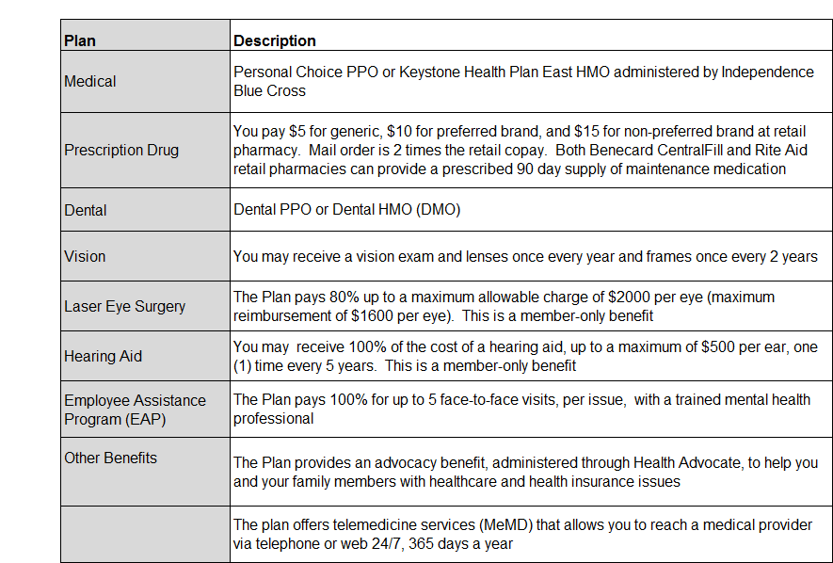

Contact Information
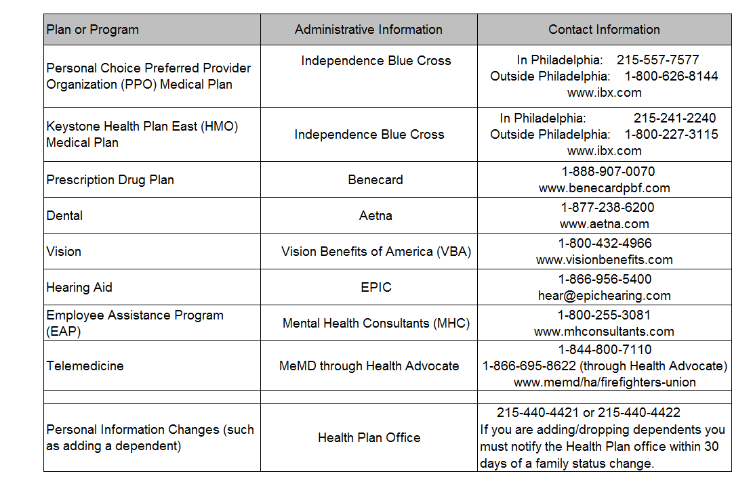

ABUSE OF BENEFITS POLICY
The great majority of our participants and dependents use only the benefits to which they are entitled. A few individuals, however, receive benefits to which they are not entitled. If any individual receives benefits to which he/she is not entitled, the Plan can terminate benefits to all family members, subtract the cost of these benefits against other benefits payable to any family member or, in the discretion of the Trustees, initiate legal action to recover the cost of the benefits. The Trustees regret having to take these actions, but they must safeguard the Plan for all deserving participants and their dependents.

ELIGIBILITY FOR COVERAGE

Who is Eligible
You and your dependents are eligible for coverage beginning with your first day of employment with the Fire Department.
- Employees
If you are employed in a position with the Fire Department that is represented by the IAFF Local 22 Union you are eligible for benefits. You may also be eligible for benefits if you are employed by an employer who has entered into a participation agreement with the IAFF Local 22 Health Plan or if you are employed by the IAFF Local 22 Union or the IAFF Local 22 Health Plan.
- Retirees
Upon retirement, you are eligible for certain benefits for five (5) years provided you meet the age and service requirements described below:
- you have reached age 45 and are eligible to participate in Plan X; or
- you have reached age 50 and are eligible to participate in Plan 87 (Plan A); or
- you have satisfied the minimum requirements to qualify for a pension benefit through the City uniformed pension plan; or
- you were a participant in the City of Philadelphia pension fund for a least ten (10) years; or
- you were employed by the Local 22 Health Plan or the Local 22 Union for a minimum of 35 hours a week for at least ten (10) consecutive years immediately preceding your retirement and you are at least 55 years of age when you leave employment with the Health Plan or the Union
    - any Health Plan or Union employee (or their eligible dependent) who is eligible to enroll in Medicare, must enroll in Medicare Part A and Part B to qualify for the five (5) years of City-funded coverage
City-funded health coverage is limited to this five (5) year period, regardless of whether you would qualify for a pension under more than one of the requirements listed above. If you die, your eligible dependents are entitled to continue coverage from the Plan for the balance of the five years of coverage remaining at the time of your death, provided they continue to meet the definition of “eligible dependent.”

Deferred Retirement Benefits
You may elect to defer your eligibility for five years of City-funded coverage until a later date. This election to defer coverage must be made when you retire and you can only re-enter coverage status one time. If you have access to other health coverage when you retire, and are interested in additional information on deferring your coverage with the Plan, please contact the Plan office prior to your retirement to discuss this option.
Service Connected Disability Retirement Benefits
If you are eligible for a service-connected disability pension from the City of Philadelphia and were a participant in the pension fund for one (1) day immediately prior to retirement, you are eligible for five (5) years of retiree health coverage.
Non-Service Connected Disability Retirement Benefits
If you are eligible for a non-service-connected disability pension from the City of Philadelphia and were a participant in the pension fund for at least ten (10) consecutive years immediately prior to retirement you are eligible for five (5) years of retiree health coverage.
Your City-sponsored retiree health coverage runs concurrently with your eligibility for continuation coverage under COBRA. This means that at the end of your five years of City-funded coverage you will NOT be offered a COBRA election. Please refer to “Continuation Coverage under COBRA” for additional details.
- Eligible Dependent of Employee who Dies in the Line of Duty
If you die in the line of duty, your widow or widower is eligible to receive lifetime benefits from the Plan. Any other eligible dependents will be covered for as long as they meet the eligibility criteria of the Plan, e.g., dependent children will be covered until they reach age 26.
- Eligible Dependent of Employee who Dies in Active Service but Not in Line of Duty
If you die while in active service but not in the line of duty, your spouse and other eligible dependents will remain eligible for coverage as if you had retired on the date of your death.

- Eligible Dependent of Employee who Dies while on Approved Leave of Absence
If you die prior to retirement, while on an Approved Leave of Absence, your spouse and other eligible dependents will remain eligible for coverage as if you had retired on the date of your death.
- Eligible Dependent of Retired Employee
If you are a retiree and die while eligible for health coverage your spouse will be covered for the remaining period of your retirement coverage. Any other eligible dependents will be covered for as long as they meet the eligibility criteria of the Plan.

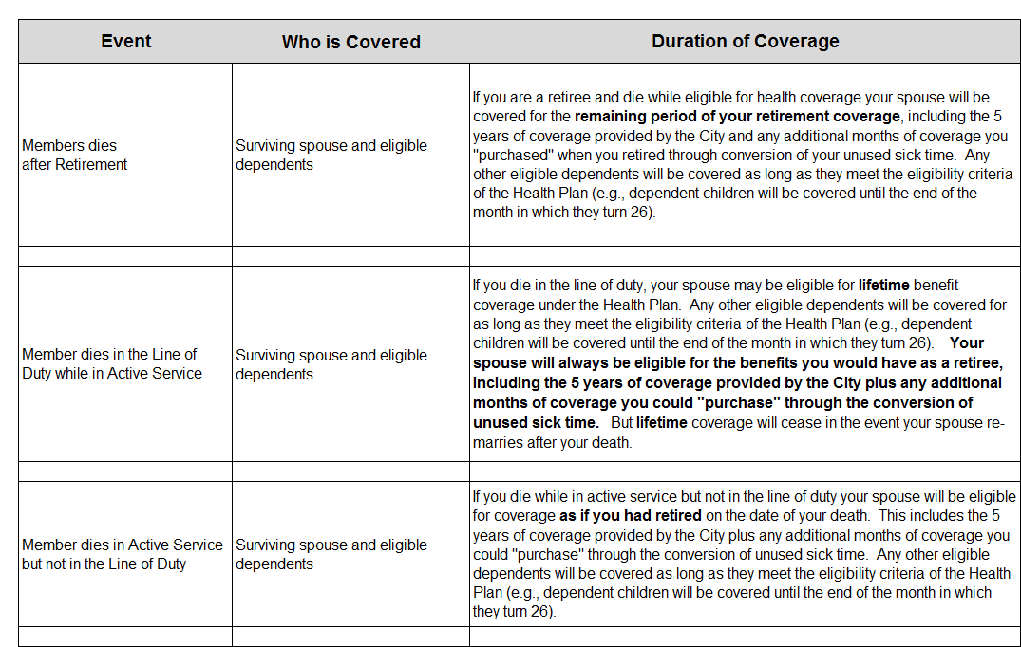
Upon your initial eligibility, the Plan will provide you with enrollment cards and application forms. You will not be eligible for health benefits until you complete and return these documents.
Enrollment in the Health Plan is not automatic. Until you complete the enrollment and application forms neither you nor your eligible dependents will be covered for health benefits

Your Eligible Dependents
Coverage is for you and your eligible dependents. Eligible dependents are your:
- Legally married spouse
- Children under age 26
- Handicapped children of any age who are chiefly dependent upon you for support and are unable to earn a living because of mental or physical handicap
Your children are your biological children, legally adopted children from the date of placement in your home, and any children for whom you are legally bound, as confirmed by a court order, to provide full and permanent support. A child may be covered until the end of the month in which he or she reaches the age limit of 26.
Your spouse or child is not eligible while they are on active duty in the armed forces of any country.
Stepchildren may be enrolled if you demonstrate that you stand in a parent-child relationship with the child. Your stepchildren are the children of a person to whom you are legally married where you are not the biological parent. You may demonstrate a parent-child relationship by providing your marriage certificate to the child’s parent as well as a copy of the child’s birth certificate. There is a fee of $65 per child per month to enroll your stepchild in the health plan, with this amount subject to change when reviewed annually by the Board of Trustees. This fee is due on or before the first day of the coverage month and failure to provide timely payment will result in a late fee of $25 per child for each month that your payment is delinquent. Continued delinquency in remitting this fee may result in termination of the stepchild’s health coverage. Coverage will also terminate in the event you and your step child’s biological parent divorce.
Waiver of Fee
You may apply for an annual waiver of the fee to enroll your stepchild if you furnish the following documentation to the Plan each year:
- If the child is under the age of 18, a current child support order that substantiates that neither you nor your spouse is receiving any financial support on behalf of the child; and
- Evidence that the child’s biological parents cannot provide health benefit coverage; and
- A copy of your tax return showing that you, or your spouse if filing separately, claim the child as a dependent. The child must be claimed as a dependent within your household; and
- a “stepchild affidavit” which affirms that you meet all requirements for eligibility, advises your liability if the stepchild is not eligible, and also affirms that neither you nor your spouse receive any financial support from any source for the child.
Grandchildren
You may enroll your grandchild if you provide the Plan with an official copy of an order from a court of competent jurisdiction awarding you permanent, legal and sole physical custody of the children.
Handicapped Children over age 26
The Plan will continue to provide health coverage for a child who is mentally or physically handicapped and incapable of supporting him or herself after their 26th birthday for as long as the child remains handicapped and unmarried and the following requirements are met:
- the child must have been handicapped and an eligible dependent under the Plan prior to reaching their 26th birthday
- you must provide medical or other documentation of the child’s handicap. Examples of documentation include a statement from a treating physician that the child is handicapped; or a determination from the Social Security Administration that the child is handicapped.
The Trustees will make the final determination, based on the documentation submitted, on whether the handicapped child can continue coverage under this provision.

Qualified Medical Child Support Order (QMCSO)
Your children also include children under age 26 for whom you are required to provide health care coverage under a Qualified Medical Child Support Order (QMCSO), regardless of where the children reside. A QMCSO is any judgment, decree, or order issued by a court requiring you to provide child support or health care coverage for a child.

Proof of Eligibility
As a condition of receiving coverage and benefits through the Plan, you must comply with reasonable requests for verification of initial and continuing eligibility. Married participants will be required to supply proof of marital status. If your child is handicapped, you must provide written evidence of the child’s handicap within 31 days after his or her attainment of age 26. When required, you must provide proof of the continuation of your child’s handicap to the Plan.
When You Need to Make Changes
You may make certain benefit changes during the year only if a change in status occurs (as outlined below). You must notify the Plan office of your request for a change in coverage within 30 days of the change in status, and you must provide proof of the event. Otherwise, you may not be able to make changes until the Plan’s annual Open Enrollment. If you fail to report that a dependent is no longer eligible you may be responsible for all costs the Plan incurs for the ineligible dependent.
The following are changes in status:
- A change in your marital status (such as marriage, divorce, or annulment)
- A change in the number of your dependents for tax purposes (such as birth, legal adoption of your child, placement of a child with you for adoption, or death of a dependent)
- Certain changes in employment status that affect benefits eligibility for you, your spouse, or child(ren) such as: termination of employment, the start of or return from an unpaid leave of absence, a change in work schedule (for example, between full-time and part-time work, decrease or increase in hours)
- Your child no longer meets the Plan’s eligibility requirement
- Entitlement to Medicare or Medicaid (applies only to the person entitled to Medicare or Medicaid)
- Change to comply with a state domestic relations order or qualified medical child support order pertaining to coverage of your dependent child
- A change in your, your spouse’s, or your child’s place of residence
- A change in your spouse’s or child’s coverage during another employer’s annual enrollment period when the other plan has a different period of coverage or following a qualified status change under the other employer’s plan
All changes must be made within 30 days of the event. If you fail to make the change within the 30 day timeframe you may have to wait until the Plan’s annual Open Enrollment

When Coverage Ends
Coverage under the Plan ends for you or a dependent on the:
- Day of your divorce or annulment
- Last day of the month for a child who reaches the limiting age
- Last day of the month in which you fail to meet the definition of “eligible employee” or “eligible retiree”

MEDICAL PLAN
The Plan provides medical coverage through two different medical plans offered by Independence Blue Cross. You may choose either Keystone Health Plan East, a health maintenance organization (“HMO”), or Personal Choice, a preferred provider organization ("PPO"). Here’s a brief description of the differences between the PPO plan and the HMO plan, to help you determine which plan best meets the needs of your family.
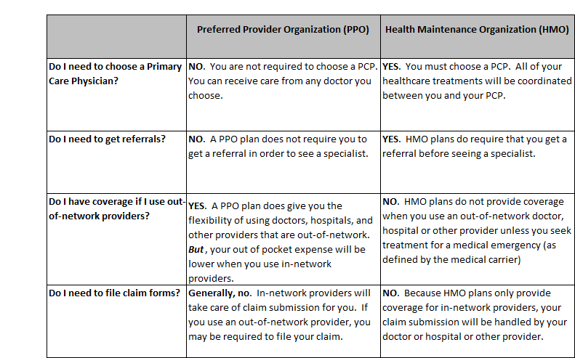

Summary of Medical Plan Benefits
Here is a summary of the benefits provided under the PPO and the HMO medical plans. For additional details on any benefit limit or exclusions please contact Independence Blue Cross or the Plan office.

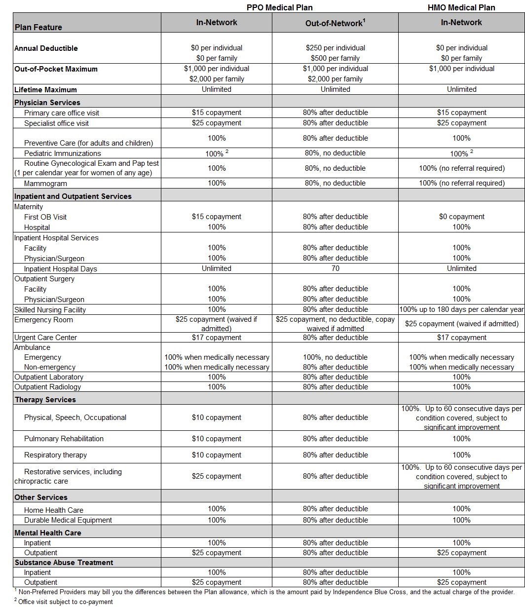

Identification Card
Once you complete the PPO or HMO enrollment form provided by the Plan office, you will receive an identification card directly from Independence Blue Cross. This ID card is for medical benefits only. Be sure to keep your ID card with you because you will need it when you receive medical care. Your Blue Cross ID card also includes phone numbers and other important information about your coverage.
Pre-Authorization of Certain Medical Care
Whether your choose the PPO or HMO, your plan includes a pre-authorization program designed to ensure that you receive the care you need, in the most appropriate setting, while avoiding unnecessary treatment.
Generally, in-network providers handle the pre-authorization process for you. If you use an out-of-network provider (PPO only, since out-of-network treatment is not covered in the HMO) YOU are responsible to confirm that your provider has pre-authorized required services. You may be responsible for a financial penalty if you do not preauthorize services when you use an out-of-network provider. There is a $1,000 penalty for failure to preauthorize inpatient services or treatment, and a 20% reduction in benefits for failure to preauthorize outpatient services or treatment.
Procedures that require pre-authorization include but are not limited to:
- Non-emergency hospital admissions (except maternity)
- Certain outpatient surgical procedures, for example:
  - Cataract surgery
  - Hemorrhoidectomy
  - Arthroscopic knee surgery
  - Tonsillectomy and/or adenoidectomy
- Transplants
- MRI/MRA
- CAT Scan
- PET Scan
- Nuclear Cardiac Studies
- Outpatient Therapies
- Non-emergency ambulance
- Infusion Therapy in home setting
This list includes some but not all of the treatment that requires pre-authorization. For complete details contact Independence Blue Cross at 1-800-ASK-BLUE. If you decide to receive treatment after review and written notification that the medical service or treatment is not authorized, benefits will not be provided and you will be financially responsible for non-authorized benefit expenses.
Open Enrollment
Each year, the Plan will give you advance notice of the “open enrollment” period. Currently, open enrollment runs through the month of November, with any changes you make effective the following January. During this time, you can change from one medical plan to the other. For example, you can move from the HMO plan to the PPO plan. Before making any change, the Trustees urge you to consider carefully each plan’s differing levels of co-payments, benefits and plan limits. If you have questions about your coverage or need additional information, please call the Plan office at 215-440-4421 or 215-440-4422.
Medical Expenses NOT Covered
Common examples of treatments, services and supplies that are not covered under the PPO and HMO medical plans include charges that are:
- Not medically necessary and appropriate, as determined by Independence Blue Cross
- Not billed and performed by a provider properly licensed and qualified to render the medically necessary treatment, service, or supply
- Experimental or investigative in nature
- Incurred prior to your effective date of coverage under the Plan
- Incurred after your coverage terminates
- For any loss sustained or expenses incurred during military service while on active duty, or as a result of enemy action or act of war, whether declared or undeclared
- That you have no obligation to pay
- For any illness or injury eligible for or covered by any federal, state, or local government program, Workers’ Compensation Law, or Occupational Disease Law or Act (this exclusion applies whether or not you claim the benefits available)
- For any occupational illness or injury
- For drugs or medicines covered under a freestanding prescription drug plan or program
- Rendered by a provider who is a member of your immediate family (“immediate family” means the member’s spouse, parent, child, sibling, or in-laws, including mother, father, sister, brother, daughter or son-in-law)
- For surgical procedures for cosmetic purposes that are done to improve appearance and from which no improvement in physiologic function can be expected; however, benefits are payable to correct a condition resulting from an accident, or to correct functional impairment resulting from a covered disease, injury, or congenital anomaly. This exclusion does not apply to mastectomy-related charges as provided for in this description
- For telephone consultations, for failure to keep a scheduled visit, or for completion of a claim form
- For custodial care
- For assisted fertilization techniques – including, but not limited to, artificial insemination, in-vitro fertilization (IVF), gamete intra-fallopian transfer (GIFT), and zygote intra-fallopian transfer (ZIFT)
- For personal hygiene and convenience items including, but not limited to, air conditioners, humidifiers, physical fitness or exercise equipment, television, guest trays, wigs, chairlifts, stair glides, elevators, spa or health club memberships, whirlpool, sauna, hot tub or equivalent device, whether or not recommended by a provider
- For acupuncture
- For care in a nursing home, home for the aged, convalescent home, or custodial care in a skilled nursing facility
- For inpatient private duty nursing services

A full description of your medical coverage, including any benefit exclusions and limitations can be provided to you directly by Independence Blue Cross. Except for issues relating to eligibility for benefits and plan administration, if there is a conflict between the Independence Blue Cross information and this booklet in the description of the medical benefits available from the Plan, the materials from Independence Blue Cross will govern.

Filing Medical Claims
When you use in-network providers, you do not need to file claim forms because in-network providers file required forms directly to Independence Blue Cross. Since the HMO provides only in-network coverage, you should not need to worry about filing any claim forms for medical benefits. Since the PPO provides coverage both in- and out-of-network, filing a claim for benefits with Independence Blue Cross may be your responsibility if you use an out-of-network provider.
Appealing a Claim Denial
The Plan has specific procedures that must be followed if your claim is denied and you wish to appeal that decision. Generally, you must appeal a denial of benefits within 180 days but there exceptions for urgent claims and for pre-authorization of medical claims. Additional information on the appeals process is included under the section entitled “Your Rights under the Plan”

PRESCRIPTION DRUG BENEFITS
The Plan provides a prescription drug benefit through Benecard PBF. Upon your initial eligibility with the Plan you will receive a prescription drug card directly from Benecard. If you have questions about your prescription benefit you can call the Plan office or contact Benecard directly at 1-800-907-0700. Additional information is available on their website at www.benecardpbf.com
The plan is 3-tiered and your copayments vary depending on whether you use a generic drug, a Formulary (“preferred”) brand name drug, or a non-Formulary (“non-preferred”) brand name drug.
Your Retail and Mail Order Copayments
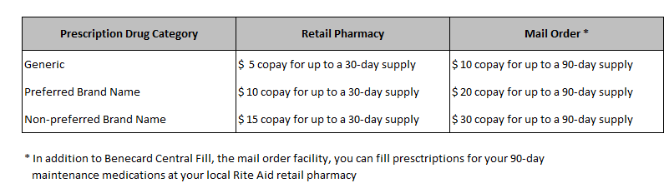
Important: If you use a brand name drug (whether preferred or non preferred) that has a generic equivalent, you will pay the copay for the brand name drug PLUS the difference between the cost of the brand name drug and the cost of the generic equivalent drug.
Non-Maintenance Medication
If your physician prescribes a non-maintenance medication you simply take your Benecard ID card to any participating retail pharmacy. Our network of participating pharmacies includes over 53,000 pharmacies nationwide. But note that Walgreen’s is NOT currently part of the participating pharmacy network. Retail prescriptions are limited to a 30-day supply. If you need more than 1 original fill, plus 2 refills, you must use the Mail Order program. Filling prescriptions through the Mail Order program means using either Benecard Central Fill or your local Rite Aid retail pharmacy.

Maintenance Medication
Maintenance medications are medications you take on an ongoing basis to treat chronic conditions like diabetes, high blood pressure, and arthritis.
If your physician prescribes a maintenance medication (prescription drugs that you are expected to take for an extended period of time) you fill your first prescription AND the next 2 refills at any participating retail pharmacy.
After your 2nd refill, your prescription must be filled through Benecard Central Fill. (For your convenience, you can also fill your maintenance medications at your local RiteAid retail pharmacy.) After your initial fill and two refills, the Plan will cover maintenance medications only if you use Benecard’s Central Fill or RiteAid retail pharmacy.

Filing Maintenance Medications
When your doctor prescribes a maintenance medication, the Plan covers your original prescription plus the first 2 refills for a 30-day supply only. This gives you and your doctor a chance to confirm that the medication and the dosage are right for you. After the 2nd refill the Plan will provide coverage for a 90-day supply through the Mail Order Program.
For information about how the mail order program works you can call Benecard at 1-800-907-0700 or the Health Plan at 1-215-440-4421/4422. Your doctor can fax your prescription to Benecard at 1-888-907-0040. And you can order your mail order refills online at www.benecardpbf.com
Step Therapy
Step Therapy is a program designed to encourage the utilization of generic medication alternatives for chronic medical conditions in order to control healthcare costs for patients and their plan sponsors. The program requires a patient to use a lower‐cost medication prior to using the “second‐line” or higher cost medication within the same therapeutic category.

A Step Therapy program requires a member to have tried a first line medication before a second line medication is approved for coverage. The list of therapeutic classes requiring step therapy includes specialty medications and is developed by doctors, pharmacists and experienced medical personnel. A sample of these classes includes proton pump inhibitors, hypertension, sedative hypnotics, rheumatoid arthritis and transplant medications.

Filling your Prescription
If you fill your prescription at a network pharmacy, you do not need to file any claim forms. Just be sure your pharmacist has a copy of your Benecard identification card and they will handle claim submission.
If you fill your prescription at a pharmacy that is not part of the Benecard network, or if you fill your prescription at a participating pharmacy but fail to use your Benecard ID number, you will be charged the total cost of the prescription at the time it is filled. You will need to file a claim with Benecard for reimbursement. And note that your reimbursement will be based on what the Plan would have paid – which may differ significantly from what you paid.
OVER THE COUNTER (OTC)
Special provisions apply to certain OTC medications, providing plan coverage and minimal copays. Note that you will need a prescription from your doctor if you want the Plan to cover the following OTC drugs:
- $ 0 copayment
  - Prilosec 20 OTC
  - Nexium OTC
- $1 copayment
- Prevacid OTC
- Allegra OTC
- Claritin OTC (brand and generic)
- Zyrtec OTC (brand and generic)
Simply present your doctor’s prescription and your Benecard ID card if you obtain any of these OTC medications.

Covered Prescription Drugs
The Plan covers medications, products or devices that have been approved by the Food and Drug Administration (FDA). This includes federal legend drugs, state legend drugs, compounded medications, insulin, and injectables.
Prescription Drug Charges Not Covered
There are some prescription drugs that are excluded from coverage under the Plan, including:

Diabetic prescription drugs and supplies
The Plan covers insulin through Benecard under our prescription drug plan. Diabetic supplies, including lancets and glucose monitors, are covered through Independence Blue Cross under our medical plan. For additional information please call the Health Plan at 215-440-4421 or 215-440-4422.
- Except as noted above, over the counter (OTC) drugs, vitamins and supplements that may be prescribed by a physician but which can be obtained without a prescription
- Prescription drugs when there is an OTC equivalent
- Fertility drugs
- Cosmetic products
- Drugs prescribed by anyone other than a licensed physician
- Prescription drugs dispensed by anyone other than a licensed pharmacist
- Drugs administered while you are an inpatient in the hospital
- Drugs that are prescribed for a diagnosis other than approved by federal or state law
- Drugs for which coverage is available from some other source, including (but not limited to) worker’s compensation, government programs, occupational disease laws
- Prescriptions that you try to refill too soon

VISION BENEFITS
The Plan provides a vision benefit program through Vision Benefits of America (VBA). While you may use any provider you choose, your out-of-pocket expense is generally less when you use a VBA-participating provider. For a list of participating providers in your area, contact VBA at 1-800-432-4966 or log on to the VBA website at www.visionbenefits.com
VBA does not provide or require a vision Identification Card. If you or one of your eligible dependents needs vision services, simply let the provider know you are covered under VBA and provide your Social Security Number.
.
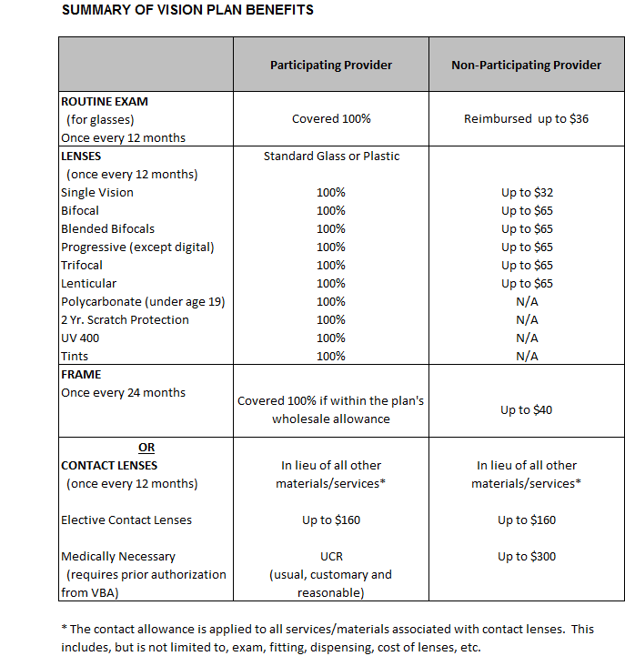

Vision Expenses Not Covered
The plan does not provide benefits for the following expenses:
- Medical or surgical treatment of the eyes
- Special procedures
- Services or materials covered under worker’s compensation or any governmental agency
- Non-prescription glasses

Laser Corrective Eye Surgery Benefit (this is a member-only benefit. Dependents, including spouses, are not eligible for the laser eye surgery benefit)
The Plan provides a laser eye surgery benefit to eligible members. There is no network of preferred providers for this benefit but your out-of-pocket expense may be lower when treatment is performed at any TLC Laser Eye Center or the Delaware Valley Laser Institute. The Plan provides reimbursement of 80% of charges up to $2,000 per eye (up to $1,600 per eye or up to $3,200 for both eyes) per lifetime.
You are responsible to pay the provider and obtain your reimbursement from VBA. To file your claim, contact VBA for a claim form. Have your provider complete the claim form, including the provider’s name/address; date of service; charges; and your name/address/social security number. Claims can be sent to VBA at 300 Weyman Plaza, Pittsburgh, PA 15236-1588.

DENTAL BENEFITS
The Plan offers two different dental programs, both administered by Aetna Dental.

Dental Maintenance Organization (DMO)
The Aetna DMO provides an unlimited annual benefit for you and each of your eligible dependents; however, you MUST use only DMO network providers. You need to select a dentist from the list of Aetna DMO providers and, if you require treatment from a dental specialist, you must get a referral from your primary dentist. If you seek treatment from a dental provider who is not in the Aetna DMO network, unless approved in advance by Aetna, no benefit will be paid.

Dental Preferred Provider Organization (PPO)
The Aetna PPO provides a $5,500 annual benefit for you and for each of your eligible dependents. Plus, you have the ability to increase your annual benefit maximum by $500/year for up to 3 years, for a total annual benefit maximum of $7,000. Just have a preventive service completed in a given year and earn an additional $500 towards your maximum for the following year. The PPO provides the flexibility of using providers who are in the PPO network and out of the PPO network. But if you use a dentist who is part of the PPO network, you will save money. Participating dentists (dentists who are in the Aetna PPO network) have agreed to a negotiated fee with Aetna and cannot bill you for amounts above this “allowed amount.” Your out of pocket expenses are any differences between what Aetna allows and the percentage that Aetna pays, as summarized on the chart below, and any amounts that exceed the annual maximum. When you use non-participating dentists (dentists who are not in the Aetna network), dental payments are based on Aetna’s allowed amount. If your non-participating dentist charges more than the allowed amount you can be billed the difference between what Aetna paid and what the dentist charged.

You must enroll in one of the dental plans before you and your eligible dependents can be covered for dental benefits. You can change from one dental plan to the other only during the Plan’s annual open enrollment period. To find a participating PPO or DMO dentist, call Aetna at 1-877-238-6200 or visit their website at www.aetna.com

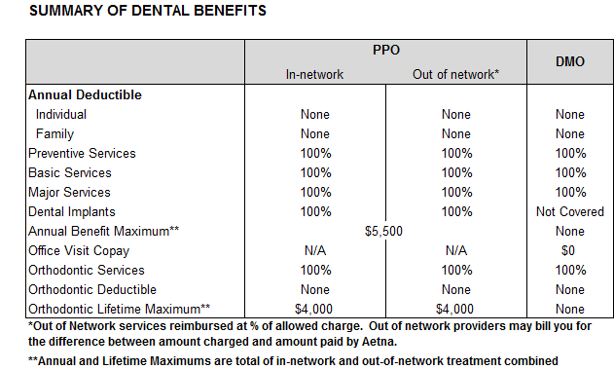

EMPLOYEE ASSISTANCE PROGRAM (EAP)

It’s Confidential
All calls to MHC, and any treatment received from MHC providers, is strictly confidential. No one, including the Health Plan, knows that you made a call to MHC or that you used an MHC healthcare provider, unless you authorize it.
The employee assistance program (EAP) is a counseling, information, and referral service that helps you address personal problems on a confidential basis. The Plan has contracted with Mental Health Consultants (MHC) to provide this benefit. All calls to MHC and any treatment received by MHC providers are strictly confidential.

MHC has a comprehensive network of quality healthcare professionals, including psychiatrists, psychologists, clinical social workers, certified nurse practitioners, and counselors who are available to help you 24 hours a day, 7 days a week, with issues like:
- Stress
- Depression
- Drug or alcohol abuse
- Relationship problems
- Marital problems
- Domestic violence
- Caring for an elderly parent
MHC participating practitioners will provide up to five (5) counseling sessions, per year, per issue. MHC defines an issue as the problem or circumstance that prompted the member to contact MHC. Although there is a limit on the number of counseling sessions you can receive, each year per issue, there is not a limit on the number of issues per year for which you can reach out to MHC. And, remember, these counseling sessions are at no cost to you. You do not pay a copayment for the 5 sessions, per issue, when you reach out to MHC.
This Health Plan EAP is available to all eligible members, their dependents, the member’s parents and the member’s spouse’s parents. If you or a family member needs assistance, call MHC at 1-800-255-3081.

OTHER BENEFITS
GUARDIAN NURSES
The Health Plan has engaged Guardian Nurses, a team of Registered Nurses, to provide advocacy services to our members and their eligible dependents. If you or your dependent is ill or injured, or if you need long-term care, Guardian Nurses can help you in the following ways:
- Visit You at Home or in the hospital to assess your care needs
- Be Your Guide, coach and advocate for any healthcare issue
- Make Appointments so you can be seen as quickly as possible
- Go With You to see doctors, to ask questions and to get answers
- Identify Providers for all care needs and second opinions
- Get Things you Need such as healthcare equipment
- Provide Decision Support when you are thinking about treatment options
- Explain a New Diagnosis to help you make informed decisions
- Coach and Support You through the challenges of a chronic disease.
All services are confidential and at no cost to you. Call Guardian Nurses at 215-836-0260 or toll free at 888-836-0260 if you can use some help navigating the healthcare system.

HEALTH ADVOCATE
The Fund has also contracted with Health Advocate to assist you or a family member with healthcare or health insurance issues. Health Advocate is a national advocacy and assistance company headquartered in Blue Bell, PA. They do not provide health insurance or medical coverage and the Health Advocate program is not a substitute for your current health plans. Rather, their services can help you handle healthcare insurance related issues. If you or a family member needs help with a healthcare insurance issue, call Health Advocate at 1-866-695-8622 or visit their website at www.healthadvocate.com

MeMD Telemedicine Service
The Health Plan offers a telemedicine service through Health Advocate called MeMD. This service allows you to reach a medical provider via telephone or web when access to your regular doctor is not available. MeMD provides a national network of US licensed physicians who are available any time, day or night, 365 days a year. You will receive a personal diagnosis and a personalized treatment plan, including prescriptions for common medications. You can access MeMD by calling 1-844-800-7110; online at www.memd.me/ha/firefighters-union or call Health Advocate at 1-866-695-8622. The Health Plan pays the entire cost. Your copayment is $0.00

Hearing Healthcare (this is a member-only benefit. Dependents, including spouses, are not eligible for this benefit)
The Health Plan offers a hearing healthcare benefit through EPIC hearing. The Plan provides the following hearing benefit:

- Hearing Exam: $70 allowance once every 2 years. You can use any provider you want, but if you use an EPIC participating provider, the hearing exam is covered in full and you have no out of pocket expense.
- Hearing Aids: $500 per ear once every 5 years.

For information about EPIC participating provider, contact EPIC at 1-866-956-5400 or log on to their website at hear@epichearing.com

OTHER IMPORTANT INFORMATION

CONTINUATION COVERAGE UNDER COBRA

The Consolidated Omnibus Budget Reconciliation Act of 1985 (COBRA) is a federal law that requires a temporary extension of health care coverage in certain specific situations. COBRA continuation coverage may be available to you and to your dependents who are covered under the Health Plan when you would otherwise lose your group health care coverage. The rights to COBRA continuation coverage apply separately to you, your spouse, and your dependent children.

Qualified Beneficiaries and Qualifying Events

COBRA provides a continuation of Plan coverage when coverage would otherwise end because of a life event known as a “qualifying event.” Specific qualifying events and the duration of continuation coverage are outlined below. COBRA continuation coverage must be offered to each person who is a “qualified beneficiary.” A qualified beneficiary is someone who will lose coverage under the Plan because of a qualifying event. Depending on the type of qualifying event, employees, spouses of employees, and dependent children of employees may be qualified beneficiaries.

You will become a qualified beneficiary if you will lose your coverage under the Plan because either of the following qualifying events occurs:

- Your employment is terminated for any reason except gross misconduct

- Your work hours are reduced

Your spouse will become a qualified beneficiary if your spouse loses coverage under the Plan because any of the following qualifying events occur:

- Your employment is terminated for any reason except gross misconduct

- Your work hours are reduced

- You die

- You become covered by Medicare

- You and your spouse divorce

Your dependent children will become qualified beneficiaries if they will lose coverage under the Plan because any of the following qualifying events occur:

- Your employment is terminated for any reason other than gross misconduct

- Your work hours are reduced

- You die

- You and your spouse divorce

- Your child ceases to meet the Plan’s definition of “eligible dependent”.

Type of Coverage

Generally, you can elect to receive the same type of group health care coverage you had immediately prior to the qualifying event. However, your benefits will change if the Plan's benefit plans change. You may also elect a less expensive level of coverage at the time you make your initial COBRA election.

Notification Requirements

You must notify the Plan Administrator, within 60 days of the qualifying event, if any of the following qualifying events occur:

- You get divorced or become entitled to Medicare

- Your child ceases to qualify as a dependent under the Plan

The Health Plan Administrator will notify you, or your qualified beneficiary, within 14 days of the qualifying event, if any of the following qualifying events occur:

- Your employment is terminated

- Your work hours are reduced resulting in loss of coverage under the Plan

- Your death

Maximum Coverage Period

Once the Plan Administrator receives notice that a qualifying event has occurred, COBRA continuation coverage will be offered to each qualified beneficiary. For each qualified beneficiary who elects COBRA continuation coverage, COBRA continuation coverage will begin on the date that coverage under the Plan would otherwise have been lost.

Note: The Plan will treat your post-retirement coverage as “alternate coverage,” within the meaning of COBRA. This means that if (1) you are eligible for post-retirement benefits coverage and (2) you elect to receive this coverage immediately upon your retirement, your COBRA continuation coverage will run concurrently with your health benefits coverage. You will not be eligible to elect additional COBRA benefits when your post-retirement benefits terminate. If, however, one of your dependents experiences a qualifying event during your post-retirement coverage and the dependent is eligible to elect COBRA coverage, the Plan will make COBRA coverage available to the dependent as required by applicable law. Additionally, if you choose to defer your post-retirement coverage, you will not be eligible to elect COBRA benefits during your deferral period.

The maximum COBRA continuation coverage period will be:
- Up to 18 months from the date coverage is lost when the qualifying event is your termination of employment or reduction in work hours.
- Up to 29 months from the date coverage is lost when you, your spouse or your dependent is determined by the Social Security Administration (SSA) to have been disabled at any time during the first sixty (60) days of COBRA continuation coverage, but only if the disabled person (or a family member) notifies the Plan Administrator of the SSA’s determination within 60 days after receipt of the notice of the decision and before the end of the 18 month coverage period.
3. Up to 36 months from the date coverage is lost in all other cases.

Second Qualifying Event
If your family experiences another qualifying event while receiving COBRA continuation coverage, your spouse and dependent children can get additional months of COBRA continuation coverage, up to a maximum of 36 months. This extension is available to your spouse and dependents if you die or divorce. The extension is also available to your dependents if they cease to meet the Plan’s definition of “eligible dependent.” In all these cases, you must notify the Plan Administrator of the second qualifying event within 60 days of the second qualifying event.

Cost of COBRA Continuation Coverage

If you, your spouse, or your dependent child(ren) choose to continue coverage under COBRA, you will be required to pay the full cost of the coverage plus 2% for Plan administration (102%). If you are disabled at the time you become eligible for COBRA continuation coverage, and you are eligible to extend continuation coverage for up to 29 months, you will be required to pay 150% of the cost of coverage after the first 18 months. Note that if only the non-disabled family members elect to continue COBRA coverage under the 11-month disability extension, the cost will remain at 102%. The Plan’s cost of coverage changes each year, so COBRA premiums are subject to change annually. You will be notified of any change in your COBRA premium.

Election of COBRA Continuation Coverage

You will have at least sixty (60) days to elect COBRA continuation coverage. This election period will end on the later of
- 60 days from the date you would otherwise lose coverage (except for making a COBRA election); or
- 60 days from the date the Plan mails your notice of COBRA continuation coverage and provides you with an election form
If you incur covered expenses during the election period before you have made an election, your claims will not be processed until the Plan receives your election forms and the payment of your first premium.

Termination of COBRA Continuation Coverage

Your COBRA continuation coverage will terminate before the end of the maximum coverage period if any of the following occurs:
- You fail to pay the premium for your COBRA continuation coverage when it is due (including any grace period).
- A qualified beneficiary becomes covered under another group health plan that does not impose any pre-existing conditions exclusion for a pre-existing condition of the qualified beneficiary.
- The Plan ceases to provide any group coverage under the Plan to any of its members.

Reinstatement of COBRA Coverage: A member who elects COBRA continuation coverage and who then terminates COBRA coverage because of Medicaid eligibility, may reinstate COBRA coverage for the balance of the maximum coverage period in the event that he or she is no longer eligible for Medicaid. You must notify the Plan Administrator within 60 days of this event.

Coordination with Subsidized Coverage: If there is a qualifying event but the employee's employer or the Plan provides coverage without charge, including coverage under the Family and Medical Leave Act of 1993, COBRA continuation coverage does not begin until the date you lose coverage because the subsidized coverage ceases. NOTE: The retiree coverage you take immediately upon retirement will be your COBRA coverage for that qualifying event.

You have at least 60 days to make an election to accept or reject COBRA coverage. If you elect COBRA coverage, your premium must be submitted with 45 days of the date of your COBRA election.

MASTECTOMIES AND RECONSTRUCTIVE SURGERY
Group plans, including this Health Plan, that provide medical and surgical benefits in connection with a mastectomy must provide benefits for certain reconstructive surgery. These benefits cover reconstruction of the breast on which the mastectomy was performed, surgery and reconstruction of the other breast to produce a symmetrical appearance, as well as prostheses and treatment of physical complications at all stages of mastectomy, including lymph edemas. This coverage will be provided in a manner determined in consultation with the attending physician and the patient, subject to the Plan’s general provisions relating to benefits, precertification and other applicable limitations. This coverage is also subject to the Plan’s annual deductibles and coinsurance provisions. If you have any questions about these coverages, please contact the Plan Office.

BENEFITS FOR MOTHERS AND NEWBORNS
Under federal and state law, when you or your dependent enters the hospital to give birth, the Plan will provide benefits for a hospital stay of at least forty-eight (48) hours following birth if the birth is a normal vaginal delivery. The Plan will provide benefits for a hospital stay of at least ninety-six (96) hours following birth if the birth is by caesarian section. You will still be responsible for any deductibles or co-payments required under the Independence Blue Cross plan you have selected.
You may, of course, elect to leave the hospital earlier than 48 or 96 hours after birth. The Plan may provide benefits for a shorter stay if your attending provider, in consultation with you, decides to discharge you earlier than 48 (or 96) hours after you give birth.
The Plan:
- cannot deny you or your child eligibility to enroll or to continue coverage under this Plan to avoid paying for the hospital stays described above;
- cannot give you or your attending provider any financial or other incentives to encourage you to accept a shorter stay in the hospital than the stays described above;
- cannot limit the amount it pays your attending provider because the attending provider determines that you should be in the hospital for 48 or 96 hour periods described above; and
- cannot pay lesser benefits or require greater out-of-pocket costs for the 48 or 96 hour hospital stay for the period after birth than it pays for a hospital stay of the same length you have prior to the birth. The Plan may not, under federal law, require that a physician or other health care provider obtain authorization for prescribing a length of stay of up to forty-eight (48) hours (or 96 hours). However, to use certain providers or facilities, or to reduce your out-of-pocket costs, you may be required to obtain precertification.

CONTINUATION COVERAGE IF YOU TEMPORARILY SERVE IN THE ARMED SERVICES
The Plan will provide continuation coverage pursuant to the terms of the Uniformed Services Employment and Reemployment Rights Act ("USERRA"), 38 U.S.C.§§ 4301 et seq., for all leaves while you are serving in the uniformed services beginning on or after October 13, 1994. The Plan will permit you to purchase continuation coverage for a period of thirty-six (36) months when you are absent for the purpose of performing service in the uniformed services. As with COBRA coverage, the employee must purchase the coverage from the Plan, unless the City provides the required contribution for coverage. The maximum amount you will be responsible to pay is 102% of the cost of coverage under the Plan’s plan of benefits. If uniformed service is less than thirty-one (31) days, you are not required to pay for coverage. This coverage will be funded by the City. Upon reemployment, you will be entitled to reinstatement of the same benefits to which you would be entitled had the service in the uniformed services not occurred. The entitlement to coverage will end if you fail to return to covered employment during the time period prescribed by USERRA. If you have a question about your rights under USERRA, please call the Plan office.

SPECIAL BENEFITS FOR EMPLOYEES CALLED TO ACTIVE DUTY IN THE NATIONAL GUARD, OR IN ANY OF THE RESERVE COMPONENTS OF THE ARMED FORCES OF THE UNITED STATES IN RESPONSE TO THE NATIONAL EMERGENCY RESULTING FROM THE EVENTS OF SEPTEMBER 11, 2001. (Note that this section applies only while the national emergency, which must be renewed each year, is in effect)
The continuation of medical and supplemental benefit programs, including dental, vision, and prescription drug coverage for the employee and eligible dependents will be provided to permanent employees of the City of Philadelphia who are called to active duty in the National Guard, or in any of the reserve components of the Armed Forces of the United States in response to the national emergency resulting from the events of September 11, 2001. These benefits will be made available to all permanent employees whose military orders have been issued on or after September 11, 2001 and will continue until it has been determined that the national emergency has ended.

COORDINATION OF BENEFITS
Sometimes individuals are covered by more than one group health plan (e.g., as a member under the Local 22 Health Plan and as a dependent under a spouse’s group health plan). If both plans paid their full benefit allowance the total reimbursement for one claim could exceed the actual claim expense, increasing the cost of health care for everyone. That’s why plans, including this Health Plan, have a coordination of benefits (“COB”) provision.
When you receive health care services that are also covered under another plan, a determination is made as to which plan is "primary" and which plan is "secondary". The primary plan will provide benefits without regard to the secondary plan. The secondary plan will then consider payment for any remaining balances according to the limitations of its program. If the Plan is the secondary payer, the Plan will not pay greater benefits than are payable when the Plan is the primary payer, after considering all benefits already paid under the primary plan.

Which Plan Pays First
When you have coverage under more than one health plan, one of the plans is considered the primary payer and pays first according to its schedule of benefits. Then the other plan (referred to as the secondary payer) may pay benefits, depending on that plan’s provisions.
Here is how the Plan determines which plan pays first:
- If the other plan does not have a coordination of benefits provision, that plan pays first
- The plan that covers the patient as a member/employee/retiree will pay benefits before the plan that covers the person as a dependent
- For children who are covered as dependents under both plans, the plan of the parent whose birthday (month and day) falls earlier in the calendar year pays first. (This is usually referred to as “the birthday rule.”) If both parents have the same birthday, the plan that covered the parent longer pays first
- If the Plan is coordinating with a plan that uses a rule based on the gender of the parent, the plan of the male parent is primary
- If a covered dependent child’s parents are divorced, the primary plan is determined as follows:
  - The plan of the parent whom a court order has ordered to have financial responsibility for health care expenses pays first (if the plan has been notified of the court order)
  - If no court order exists, the plan of the parent with custody of the child pays first
  - The plan that covers the person as an active employee will pay benefits before the plan that covers the person as an inactive employee or dependent

If none of the rules above apply, the plan that has covered the patient for the longest period of time pays first.

The Plan may release to or obtain from any person or organization, any information about coverage, expenses and benefits which may be necessary to coordinate benefits as part of its “payment” function, consistent with HIPAA’s Privacy Rule (See “HIPAA Privacy Practices”). The employee on his/her own behalf and on behalf of their dependent(s) may be required to furnish information and to take such other action as is necessary to assure the rights of the Plan.

SUBROGATION AND REIMBURSEMENT AGREEMENT
The purpose of this Section is to insure that the limited funds available to finance the benefits provided by the Plan are not used to provide benefits where other funds may be available to pay the cost of the benefits provided by the Plan. In furtherance of this purpose, in the event that the Plan has made, does make or is obligated to make payments to or on behalf of a Participant or Dependent (“Participant”) arising out of any Illness or Injury then, as a condition for receiving benefits from the Plan, the Participant shall:
- Notify the Plan, in writing, that a Claim relating to such Illness or Injury has been filed by the Participant against a third party seeking Available Funds,
- Notify the Plan, in writing, of the name and address of the Participant's attorney, provide the attorney with a copy of this Section and any Subrogation/Reimbursement Agreement (“Agreement”) the Plan may require the Participant to sign in order to receive benefits and require that the attorney comply with the terms of this Section and of any such Agreement.
- Keep the Plan informed, in writing, of the progress and/or settlement of his/her Third Party Claim.
- Include in all Claims, a claim for benefits paid by the Plan to or on behalf of the Participant and/or claimed from the Plan by or on behalf of the Participant.
- Specifically grant the Plan a first right of reimbursement and reimburse the Plan that portion of the Available Funds which is due to the Plan for benefits paid to or on behalf of the Participant as well as for any premiums and other payments paid on behalf of the Participant to continue health insurance and/or other coverage pursuant to the provisions of the Plan. The right of reimbursement granted to the Plan by the Participant includes the right of the Plan to seek reimbursement from any person or entity that holds the Available Funds, including but not limited to, a legal guardian, representative, trustee, parent or dependent.
- Specifically grant to the Plan subrogation and all rights of recovery and causes of action that the Participant may have against the third-party, whether by suit, settlement or otherwise, that may be liable for the Participant’s Illness or Injury for which the Plan has paid or is obligated to pay benefits on the Participant’s behalf.
- Hold in trust for the Plan’s benefit that portion of the total recovery from any source that is due for payments made or to be made. The Participant shall reimburse the Plan immediately upon recovery. Without regard to how, or with respect to whom, Available Funds are held or titled, the Participant (or any dependent or beneficiary) who recovers, and any other person who holds (or who has any title to), such Available Funds shall be considered a fiduciary with respect thereto and may not assign, transfer, pledge, encumber, alienate, spend, or dispose of, the Available Funds.
- Do nothing to impair, release, discharge or prejudice the Plan’s rights to subrogation and/or reimbursement. The Participant shall assist and cooperate with representatives the Plan designates. The Participant shall do everything necessary to enable the Plan to enforce its subrogation and reimbursement rights.
- Require and authorize Participant’s attorney, if any, to withhold from Available Funds any monies due the Plan pursuant to this Section and/or the Agreement and to forward them to the Plan as required by this Section and/or the Agreement. In case of any dispute over what monies are due the Plan, Available Funds shall be escrowed pending resolution of such dispute.
Future Benefits. The Plan will not pay for any future medical services arising from and/or related to the Illness or Injury unless a mutually agreed-upon amount of the Available Funds are set-aside for the payment for such services. Further, in accordance with the Plan’s “Erroneous Payments” and “Participant Indebtedness to the Plan” provisions, should a Participant fail to comply with the provisions of these provisions, the Trustees may take any reasonable action to recoup the benefit paid hereunder (together with interest and, where applicable, costs) including, without limitation, by offsetting future benefits and/or payments.
Counsel Fees. The Plan shall have no obligation to pay any attorney's fees to any attorney retained by the Participant to pursue Third Party Claims or to have any attorney's fees or costs withheld from amounts due to the Plan. The Plan shall not be bound by any agreement to the contrary made by the Participant. The Participant shall be solely responsible for paying all legal fees and expenses in connection with any recovery and the Plan’s recovery shall not be reduced by such legal fees or expenses unless the Plan Administrator, in his/her sole discretion, agrees in writing to discount the Plan’s claim.
Right to set-off. The Participant agrees that in the event that the Participant fails or refuses to comply with the provisions of this Section and/or the Agreement, then the Plan, in addition to any other rights to which the Plan or the Trustees thereof might have, shall have the right to withhold from any payments due or which become due to the Participant or to third parties on behalf of the Participant any amounts necessary until the Plan is fully reimbursed as described in this Section and/or the Agreement.
Recording or use. The Participant hereby authorizes the Plan to record and/or use this Section and/or the Agreement in any proceedings involving the Participant including using this Section and/or the Agreement in any Third Party Claims that the Participant may have.
Authorization to pay. The Participant hereby authorizes any person or entity paying Available Funds to or on behalf of this Participant to pay over to the Plan such monies as the Plan is entitled to under this Section and/or the Agreement and this Section and/or the Agreement shall constitute their warrant to do so. In case of any dispute over what monies are due the Plan, Available Funds shall be escrowed pending resolution of such dispute.
Minors. Any Participant making a Claim on behalf of any minor child under the Plan's plan of benefits shall make the Agreement on behalf of said minor child and agrees that he/she is authorized to make the Agreement on behalf of said minor child.
Other Insurance. It is agreed that benefits payable under the Plan will be secondary to benefits provided or required by workers’ compensation, or any group or individual automobile, homeowner’s or premises insurance, including medical payments, personal injury protection, or no-fault coverage, regardless of any provision to the contrary in any other policy of insurance. It is further agreed that any payment received by a Participant from any health insurance carrier, from Blue Cross, from Blue Shield or from any like or similar plan for which the Participant has paid the full premium in order to secure individual, as distinguished from group, coverage shall be excluded from the requirements of this Section and/or the Agreement.
Rejection of make-whole doctrine. The application of the make-whole doctrine is specifically disavowed by the Plan and by the Participant. The Participant agrees that the Plan’s right to reimbursement, as set forth above, takes first priority on a first-dollar basis over any other claims, regardless of whether or not Participant has been fully compensated for all claims for damages or whether the Available Funds include payment for medical or non-medical expenses or are so characterized.
Equitable Lien/Constructive Trust. By making payments on behalf of the Participant, the Plan is granted an equitable lien by agreement and constructive trust over the Available Funds, to which the Participant consents.
Rejection of Common Fund doctrine. Participant agrees to the Plan’s express rejection of Common Fund doctrine. The Plan’s reimbursement and subrogation rights apply to any recovery by a Participant without regard to legal fees and expenses of the Participant.
For purposes of this Section, the following terms shall be defined as follows:
- The term “Participant” shall mean any participant in the I.A.F.F. Local 22 Philadelphia Fire Fighters Union Health Plan together with any dependent and/or beneficiary of any participant who may be entitled to benefits under the terms of the plan of benefits, as well as any parent(s), heir(s), estate(s), trust(s), guardian(s), representative(s) and any other person or entity that may be entitled to or that may receive a benefit from the Plan.
- The term "Illness or Injury" shall mean any illness or injury of whatever kind or description, whether arising out of a work related cause or whether unrelated to work of the Participant.
- The term "Available Funds" shall mean monies recovered from third parties through a lawsuit, settlement or otherwise (whether called pain and suffering, weekly indemnity, workers compensation, damages, restitution, wage loss, medical reimbursement, out of pocket expenses or any other term) as a result of the injury or illness.
- The term “Plan” shall mean the I.A.F.F. Local 22 Philadelphia Fire Fighters Union Health Plan
(5) The terms "Claim" or "Third Party Claim" shall mean any claim for monetary or non-monetary compensation of whatsoever kind or description whether made by petition (e.g. workers' compensation petition), court complaint, insurance claim or whether merely by written or oral demand.
Participant Indebtedness to the Plan. The Plan shall have the right to deduct from, or offset against, the payment of any benefits to which a Participant, Dependent, or designated Beneficiary shall be entitled, any sum to which the Participant is indebted to the Plan for any purpose whatsoever.
Erroneous Payments. Notwithstanding any other provision of the Plan to the contrary, any person who receives a benefit (including a payment) under the Plan shall be required to repay to the Plan: (1) any erroneous payment made to or on behalf of such person, including the value of any benefit erroneously provided, whether due to administrative mistake or otherwise; (2) appropriate interest; and (3) in the case of fraud or misrepresentation or in the event repayment is contested, any and all costs of collection (including attorney’s fees). In addition, the Trustees may take any reasonable action to recoup such erroneous payment or benefit, together with interest, and where applicable, costs, and including, without limitation, by offsetting future benefits and/or payments.

ASSIGNMENT OF BENEFITS
Neither you nor any of your eligible dependents covered under the Plan may transfer ownership of Plan benefits to anyone else. But benefit payments will be made directly to your health care provider when required.

EXCLUSIONS
In addition to the exclusions imposed by Independence Blue Cross, Aetna Dental, Benecard, Vision Benefits of America or other Plan providers, the Plan does not provide benefits under the following circumstances:
- For dates of service before you are eligible for coverage with the Plan or after your coverage with the Plan terminates
- For services that are not medically necessary
- For services received that were not contemplated by the Trustees as covered benefits under the Plan
- For services for which you have no legal obligation to pay
- For services payable under workers' compensation, "injured on duty" coverage, or other employer liability laws
- For charges for personal items provided during inpatient treatment (e.g. hospital telephone or television charges) or recommended as part of outpatient treatment (e.g., air conditioners, air filters)
- For services for which another plan should be the primary payer under the Plan's Coordination of Benefits rules
- For charges incurred because you were injured while committing an illegal act
- For charges incurred from services that are experimental or investigational
- For charges incurred because you or your dependents did not comply with the administrative requirements of the Plan, including, but not limited to, providing accurate and current information to the Plan.
¹ Medically Necessary. In determining whether a service is medically necessary, the Trustees will use the following factors: a) the service is provided in accordance with medical and surgical practices and standards prevailing in the community at the time of treatment; and b) the service is commonly and customarily recognized throughout the physician's specialty as appropriate in the treatment of the diagnosed disease, injury or illness; and c) the service is furnished to the participant or dependent at an appropriate level of care; and d) the service is not experimental or investigational or custodial in nature; and e) the service is not mainly for the purpose of medical or other research; and f) the service must not be provided for the convenience of the physician, hospital or any other provider or individual; and g) the service is determined, in the sole discretion of the Trustees, to be medically necessary.
² Experimental, Investigational. The Trustees will determine whether a procedure is
experimental or investigational by reviewing a number of factors, including, but not limited to, whether the procedure has been subject to formal studies and scientific evaluation or clinical trials; how often and how recently the procedure has been performed for treatment of the individual's specific condition; whether
standards have been established for the use of the procedure; and whether governmental bodies made determinations concerning the effectiveness of the service.

YOUR RIGHTS UNDER THE PLAN
If your claim for benefits is denied, in whole or in part, you have a right to appeal that decision.
There are 2 ways to appeal a denial of benefits: an internal appeal and an external appeal.
Internal Appeal Process
There are 3 steps to the internal appeal process:
1. You file a claim for benefits
2. Your claim is denied, in which case you are entitled to an explanation of the denial:
- Within 15 days if you are requesting pre-authorization for a treatment or service
- Within 30 days if you are requesting payment of medical services already received
- Within 72 hours for urgent care cases
- You file an internal appeal by
  - Completing all forms required by the plan administrator
  - Submit any additional information that you want considered under your appeal, e.g., additional documentation from your physician
You must file an internal appeal within 180 days of receiving notice that your claim was denied. If your internal appeal is denied, you can file for an external review. If you have an urgent care situation, you can ask for an external review at the same time as your internal appeal.

How Long does an Internal Appeal Take?
Your internal appeal must be completed within 30 days if your appeal is for a service or treatment that you have not yet received.
Your internal appeal must be completed within 60 days if your appeal is for a service or treatment that you have already received.
And at the end of the internal appeals process, the plan administrator must provide you with a written decision. If your appeal is denied, you may request an external review. The plan administrator will advise you how to file an external appeal.
For urgent care treatment or service you can request an external review even if you haven’t completed the internal appeal process. A final decision must be provided at least within 4 business days after your request is received.

External Appeal Process
If the Health Plan denies your appeal you may choose to have an independent review organization (IRO) decide whether or not to uphold the Plan’s decision. This additional process is called an external appeal. There are 2 steps to the external review process:
  - You file a written request for an external review within 60 days of the date the plan administrator sent you a final decision
    - Your request must include a brief description of why you disagree with the Plan’s denial
    - You can submit additional information for consideration of your external review request, e.g., physician notes and reports
  - An external reviewer either upholds the plan administrator’s decision or decides the appeal in your favor. The plan administrator is required, by law, to accept the external reviewer’s decision.
Your external review will be decided as soon as administratively possible, but no later than 60 days after the request was received.

HIPAA PRIVACY PRACTICES
THIS NOTICE DESCRIBES HOW MEDICAL INFORMATION ABOUT YOU MAY BE USED AND DISCLOSED AND HOW YOU CAN GET ACCESS TO THIS INFORMATION. PLEASE REVIEW IT CAREFULLY.

We are providing this Notice from the I.A.F.F. Local 22 Philadelphia Fire Fighters Union Health Plan (referred to in this Notice as the “Plan”) in order to inform you about the way that your health information may be used by the Plan. A federal law, the Health Insurance Portability and Accountability Act of 1996 (“HIPAA”), provides your health information with important protection.

The Plan is required by federal law to maintain the privacy of your protected health information (“PHI”). The Plan is also required by federal law to provide you with this description of the privacy policies and practices adopted by the Plan. The Plan must follow these policies and practices, but as permitted by law, the Plan reserves the right to amend or modify these privacy policies and practices.

Changes in our policies and practices may be required by changes in federal and state laws and regulations. Regardless of the reason for the change, we will provide you with notice of any material changes within sixty (60) days of the date the change is adopted. The effective date of this notice is September 1, 2016.

Under HIPAA, how can the Plan use my protected health information (“PHI”)? The Plan can use your PHI to facilitate your treatment, to make or obtain payment for your treatment and for health plan operations, including administration, oversight, and other legal purposes.

How may the Plan use my protected health information (“PHI”) with respect to payment for my treatment? The Plan may use your PHI for the broad range of actions needed to make sure that the Plan can make payment for the services you and your family receives. The Plan may use your PHI for making payment to providers for services or treatment you received, for making arrangements for payment through one of the networks of providers through which the Plan provides benefits to you, as well as for coordinating payment to providers though other health plans under the Plan’s coordination of benefits rule. For example, the Plan provides participants with access to a network of providers outside this immediate geographic area. The Plan may provide your PHI to the network and directly to the provider in order to ensure that the provider receives the appropriate payment for the services that have been provided to you.

How does HIPAA permit the Plan to use my protected health information (“PHI”) with respect to “health care operations?”
The Plan may use your PHI for a broad range of actions required to assess the quality of the Plan’s plan of benefits as well as for its administration and operations. These activities include, but are not limited to, ensuring that participants or their beneficiaries are eligible for benefits prior to making payment; taking corrective action to recoup overpayments and assessing health plan performance; reviewing the Plan’s plan of benefits and determining whether a reduction in costs is possible; continuing case management and coordination of care; commissioning and reviewing actuarial studies relating to the cost of benefits and management studies relating to the operation and administration of the plan; resolving internal grievances; and undertaking medical review, legal, and auditing functions. For example, the Plan may use PHI to determine the most cost-effective manner of providing benefits to its participants and beneficiaries.

May the Plan use my protected health information (“PHI”) for purposes besides payment and health care operations? Yes. HIPAA permits the Plan to use your PHI for a number of other purposes, including informing you of treatment alternatives or other health–related benefits that may be of interest to you.

Because my spouse takes care of the family paperwork, my spouse often calls to find out the status of my health claims and to get other information about me or my benefits. Can the Plan release information relating to payment of my claims to my spouse? Unless you tell the Plan otherwise, the Plan will provide claims payment information to your spouse without requiring an authorization from you. If you do NOT wish the Plan to provide your spouse with this information, you must tell the Plan in writing that you do NOT wish the Plan to release claims payment information to your spouse.

NOTE: If you wish the Plan to release other information to your spouse, please file an authorization form with the Plan office. You can obtain release forms by calling the Plan office.

May I call the Plan to get information about my children’s health claims? The Plan will provide a minor child’s parent, guardian (or person standing in loco parentis with respect to the child) with payment information about the child’s claim. The Plan will carefully consider your written request for information other than claims payment information and will respond as permitted by these privacy policies and applicable state law. NOTE: If your child is not a minor, the Plan generally cannot provide you with the child’s protected health information, even if the child is still covered under this Plan as your dependent.

Does HIPAA permit the Plan to disclose my protected health information (“PHI”) to my employer or insurer? Under HIPAA, the Plan generally cannot disclose your PHI to your employer without your written authorization. It is important to note, however, that HIPAA does permit the Plan to disclose your PHI without your authorization to workers’ compensation insurers, state administrators, or others involved in the workers’ compensation systems to the extent the disclosure is required by state or other law.

May the Plan release my protected health information (“PHI”) to the Plan’s plan sponsor? HIPAA does permit the Plan to disclose information to the “plan sponsor” for administrative functions. Here, the “plan sponsor” is the Plan’s Board of Trustees. The Plan may provide summary health information to the plan sponsor so that the plan sponsor may solicit premium bids or modify, amend, or terminate the plan.

May the Plan release my protected health information (“PHI”) to law enforcement or other governmental entities? Your PHI may be disclosed to law enforcement agencies, without your authorization or permission, to support government audits and inspections, to facilitate law- enforcement investigations, and to comply with government-mandated reporting. Note, however, that the Plan may not disclose your PHI if you are the subject of an investigation that does not arise out of or is directly related to your receipt of health care or public benefits. In addition, the Plan may disclose your PHI in the course of a judicial or administrative proceeding if the Plan receives a court order, subpoena, discovery request or other lawful process. Before releasing this information, the Plan will make reasonable efforts either to notify you or to obtain an order protecting your PHI.

Would the Plan release my protected health information (“PHI”) if my health or safety or public health or safety would be jeopardized if it did not? If the Plan has a good faith belief that your health or safety or public health or safety would be jeopardized if it did not disclose the information, the Plan will do so, after consideration of appropriate legal and ethical standards.

Must the Plan have an authorization to release my protected health information (“PHI”)?
Yes. For example, the following uses and disclosures of your PHI will be made only with your written authorization:
- Uses and disclosures for marketing purposes;
- Uses and disclosures that constitute the sale of PHI; and
- Most uses and disclosures of psychotherapy notes (if the Plan maintains any psychotherapy notes).
Any other disclosure or use of your PHI for any other purpose not described in this notice requires your written authorization. This means that if you want your friend, relative, or union representative to check on the status of a claim you submitted or to advise when or if payment will be made, you must sign an authorization form and submit it to the Plan Office. If you change your mind after authorizing a use or disclosure of your PHI, you may submit a written revocation of the authorization. However, your decision to revoke the authorization will not affect or undo any use or disclosure of information that occurred before you provided written notice to the Plan of your decision to revoke the authorization.

May the Plan use or disclose my genetic information for underwriting purposes? No. The Plan is prohibited from using or disclosing genetic information for underwriting purposes.

Do I have any rights to information under the federal privacy standards? Your rights to information under HIPAA include:
- the right to request restrictions on the use and disclosure of your PHI. The Plan will carefully consider, although is not required to honor, your request for restrictions;
- the right to restrict confidential communications concerning your medical conditions or treatment if you believe that disclosure of this information could endanger you (this means, for example, that you can make a written request that the Plan send information about your medical treatment to a post office box or an address different from your home address in order to ensure that your PHI remains confidential). The Plan will attempt to honor reasonable requests;
- the right to opt out of receiving fundraising communications prepared by or for the Plan;
- the right to inspect and copy your PHI. The Plan may charge a reasonable fee for copying, assembling and postage;
- the right to an electronic copy of electronic medical records. The Plan will make every effort to provide access to PHI in the form or format you request, if it is readily producible in such form or format;
- the right to get notice of a breach of any of your unsecured PHI;
- the right to amend or submit corrections to your PHI. If you believe that the information in your records is inaccurate or incomplete, you may submit a written request to correct these records. The Plan may deny your request if, for example, you do not include the reason you wish to correct your records or if the records were not created by the Plan;
- the right to receive an accounting of how and to whom your PHI has been disclosed if it was disclosed for reasons other than payment or health care operations. Your written request for information must be submitted to the Plan and should state the period of time for which you are requesting an accounting;
- the right to file a complaint, that your privacy rights have been violated, with the Plan and the Secretary of U.S. Department of Health & Human Services. NOTE: you will not be penalized or otherwise retaliated against for filing a complaint;
- the right to receive a printed copy of this notice. You can find this notice on the Plan's website at www.iaff22.org. and at www.pfmfitness.com. Please contact the Plan office for authorization forms for release of PHI.
Complaints? Comments? Requests? The Plan has designated the Plan Administrator as the Privacy Officer. If you wish to request information which you have a right to receive, want to file a Complaint with the Plan or if you have any comments or questions regarding this notice, please contact Kathleen Corcoran at kcorcoran@iaff22.org. Please note that the Plan can assess reasonable charges for copying and assembling documents you request as well as for postage.

The Women’s Health and Cancer Rights Act of 1998
Under a federal law called the Women’s Health and Cancer Rights Act of 1998, the Plan is required to provide you benefits for mastectomy related services and to provide you with notice of your eligibility for these services.
The Women’s Health and Cancer Rights Act provides benefits for mastectomy related services including reconstruction and surgery to achieve symmetry between the breasts, prostheses, and complications resulting from mastectomy, including lymph edema. The Plan’s plan of benefits includes health benefits coverage through Keystone Health Plan East and the Independence Blue Cross Personal Choice plan. These plans include co-payments and deductibles that can apply to any services you receive from a physician or hospital, including services related to a mastectomy. Please review the summary plan description for the details on any applicable co-payments or deductibles. You can learn more about your benefits from the Plan office at 215-440-4421 or 215-440-4422.

