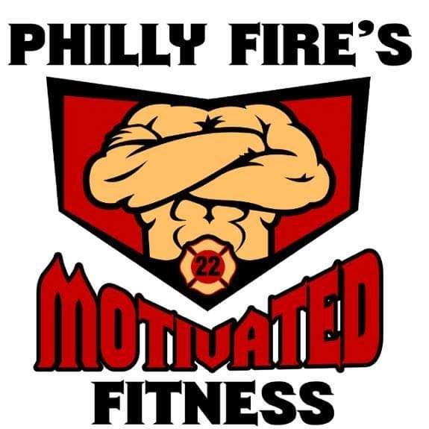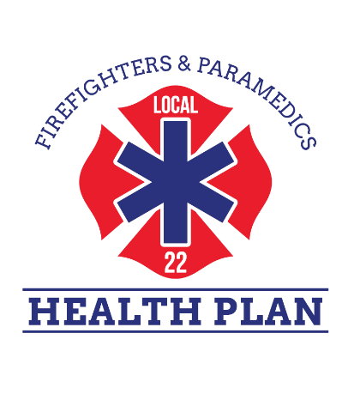

Philly Fire’s Motivated Fitness
HIRING!!!
Due to the great response from our Local 22 Health Plan Members, Philly Fire’s Motivated Fitness is looking to hire, and train dedicated Peer Fitness Trainers! Over 650 Health Plan members are taking advantage of our Peer Fitness Training: Personal Training, Fire Fighting Functionality, Nutrition, Group Fitness, our running group. With the overwhelming response trainers are in need!

Application Process:
Deadline: March 29, 2019 @ 1600 (4pm)
Email: all applications to Jstankiewicz@iaff22.org, please include any pertinent information and background information that may assist us in the hiring process, along with your name, payroll, station, platoon, and best number to contact you on.
Interviews: will be held on April 8th A/B & April 9th C/A
Contact: John Stankiewicz
Office: 215 440 4433
Cell: 215 833 9675

